Kyle Rayner

ksrayner@deakin.edu.au

Abstract

This report highlights my research efforts regarding a suitable architecture for the Smart Bike project. This involves a comparison of several viable systems/protocols including MQ Telemetry Transport (MQTT), Kubernetes and Docker Instances. The report also showcases a suitable architecture that we can use.

Sensor Architecture Report

SIT374 – Team Project (A) – Project Management and Practices

Contents

Introduction 2

Comparisons 2

MQ Telemetry Transport (MQTT) 2

Kubernetes 2

Docker Instances 3

Architecture Provided by Adrian Grigo 3

Suitable Architecture 4

Conclusion 5

References 5

# Introduction

This report will present my findings regarding a suitable architecture for the Smart Bike project being developed by Redback Operations. The report begins with a comparison of several viable systems/protocols highlighting the advantages and disadvantages of each method. Thereafter, the report looks at an architecture provided by Adrian Grigo which he used for several other projects. Finally, the report showcases a suitable architecture that we can use for the Smart Bike Project.

# Comparisons

In this section of the report, I will be comparing several viable systems/protocols we can use in our architecture. These include MQ Telemetry Transport (MQTT), Kubernetes and Docker Instances. I will highlight the advantages and disadvantages of each method below.

## MQ Telemetry Transport (MQTT)

MQ Telemetry Transport (MQTT) ‘is a lightweight open messaging protocol that provides resource-constrained network clients with a simple way to distribute telemetry information in low-bandwidth environments‘ (Bernstein, Brush 2021). MQTT has become a top contender in the world of IoT projects and for good reason. I have included a table below showcasing the advantages and disadvantages of MQTT.

|  |  |
| --- | --- |
| **Advantages** | **Disadvantages** |
| High reliability (Minteer n.d.) | Speed and latency issues (Hubschmann 2021) |
| Low energy consumption (Hubschmann 2021) | Not much security (Hubschmann 2021) |
| MQ Telemetry Transport is  relatively lightweight (Hubschmann 2021) | No support for video streaming (Hubschmann 2021) |
| Reasonably high scalability (Minteer n.d.) | Some IoT devices don’t have the processing power to run MQTT (Hubschmann 2021) |

## Kubernetes

Kubernetes ‘is an open-source system for automating deployment, scaling, and management of containerized applications’ (Kubernetes n.d.). It is commonly referred to as ‘K8s’ and is the newest method covered in this report with an initial release date of 2014. I have included a table showcasing some of the advantages and disadvantages below:

|  |  |
| --- | --- |
| **Advantages** | **Disadvantages** |
| Offers automated containerization  (Matherson 2022) | Can be reasonably complex  (Thiry 2019) |
| Thriving open-source community  (Matherson 2022) | Potentially more expensive than some of the alternatives (Dutta 2022) |
| Has a high scalability  (Tozzi 2021) | Not so great for reasonably simple projects and applications (Dutta 2022) |
| Potentially higher security than  other protocols (Tozzi 2021) |  |
| Provides storage orchestration  (IBM Cloud Team 2022) |  |

## Docker Instances

Docker ‘is an open platform for developing, shipping, and running applications’ (Docker Inc. n.d.). It has become relatively popular over the past couple years when it comes to IoT applications and projects. Below is a table outlining some of the advantages and disadvantages:

|  |  |
| --- | --- |
| **Advantages** | **Disadvantages** |
| High level of security (Singh 2017) | Can be difficult to learn (Nick 2020) |
| Supports multi-cloud platforms (Singh 2017) | Not so great for graphical interfaces  (Tozzi 2017) |
| High level of scalability and  modularity (Singh 2017) | Data storage not always so simple  (Tozzi 2017) |
| Not very resource intensive (Nick 2020) |  |
| Is very portable across platforms and often quick to develop in (IBM Cloud Team 2022) |  |

# Architecture Provided by Adrian Grigo

Figure – Architecture for a similar project provided by Adrian Grigo

Adrian Grigo, the team leader of the IoT and Embedded Systems team, provided an architecture that we might be able to use for this project with some modifications. The architecture that Adrian Grigo provided can be found in figure 1 above. This particular architecture was used for two different projects with one of them using an internet connected soil humidity sensor.

# Suitable Architecture

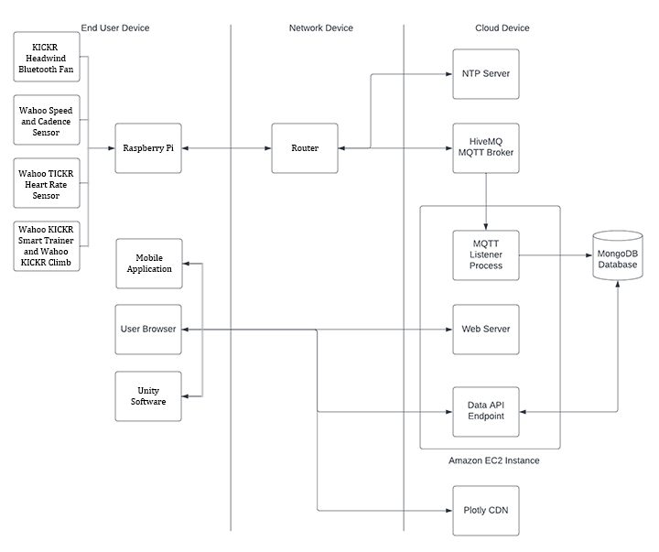

Figure – Suitable Architecture based on the architecture provided by Adrian Grigo and modified by myself

Based on my research, I have provided a suitable architecture that uses the MQTT protocol above. As the architecture provided by Adrian Grigo already used MQTT, I modified it to better reflect the Smart Bike project. As a result, I have replaced the SENO193 Moisture Sensor with the sensors that we will be using (links provided below). I have added both the Mobile Application and Unity Software components to the End User Device section where the User Browser component is. I didn’t remove the User Browser component as I am not sure if there are plans to incorporate that to some extent. For example, have an account where you can log in and see your past workouts from a browser. I have been informed that work is being done to see if the mobile application in development can listen directly to MQTT which would change the architecture slightly but would fundamentally function the same.

Wahoo KICKR Headwind Bluetooth Fan: <https://au.wahoofitness.com/devices/indoor-cycling/accessories/kickr-headwind-buy-au>

Wahoo Speed and Cadence Sensor: <https://au.wahoofitness.com/devices/bike-sensors/speed-and-cadence-sensors-bundle>

Wahoo TICKR Heart Rate Sensor: <https://au.wahoofitness.com/devices/heart-rate-monitors/tickr-buy>

Wahoo KICKR Smart Trainer: <https://au.wahoofitness.com/devices/indoor-cycling/bike-trainers/kickr-buy>

Wahoo KICKR Climb Indoor Grade Simulator: <https://au.wahoofitness.com/devices/indoor-cycling/accessories/kickr-climb-buy>

# Conclusion

This report has looked at and compared multiple viable systems/protocols that could be used for the Smart Bike project. From my research, I would state that the architecture that Adrian Grigo provided is a viable and established method which will suit out project needs well. There are certainly other systems/protocols available that we could use if decided upon, but MQTT will fulfil the requirements of the project.

# References

Bernstein C, Brush K (2021) MQTT (MQ Telemetry Transport), TechTarget, accessed 1 August 2022. <https://www.techtarget.com/iotagenda/definition/MQTT-MQ-Telemetry-Transport>

Docker Inc. (n.d.) Docker overview, Docker Inc., accessed 1 August 2022. <https://docs.docker.com/get-started/overview/>

Dutta S (2022) Kubernetes: Advantages and Disadvantages, Read Us 24x7, accessed 1 August 2022. <https://readus247.com/the-pros-and-cons-of-kubernetes/>

Hubschmann I (2021) The Pros and Cons of Using MQTT Protocol in Iot, Nabto, accessed 1 August 2022. <https://www.nabto.com/mqtt-protocol-iot/>

IBM Cloud Team (2022) Kubernetes vs. Docker: Why Not Both?, IBM, accessed 1 August 2022. <https://www.ibm.com/cloud/blog/kubernetes-vs-docker>

Kubernetes (n.d.) Production-Grade Container Orchestration, Kubernetes, accessed 1 August 2022. <https://kubernetes.io/>

Matherson N (2022) 9 Key Benefits of Using Kubernetes in 2022, ContainIQ, accessed 1 August 2022. <https://www.containiq.com/post/benefits-of-kubernetes>

Minteer A (n.d.) Analytics for the Internet of Things (IoT) by Andrew Minteer, O’Reilly, accessed 1 August 2022. <https://www.oreilly.com/library/view/analytics-for-the/9781787120730/db65d957-cf17-459c-a203-4b8234a14261.xhtml>

Nick (2020) Docker Containers: Advantages and Disadvantages, Iron, accessed 1 August 2022. <https://blog.iron.io/docker-containers-the-pros-and-cons-of-docker/>

Singh P (2017) Docker Containers and IoT Applications, IOT BYTES, accessed 1 August 2022. <https://iotbytes.wordpress.com/docker-containers-and-iot-applications/>

Thiry D (2019) Kubernetes: Advantages and Disadvantages – The Business Perspective, DevSpace, accessed 1 August 2022. <https://devspace.cloud/blog/2019/10/31/advantages-and-disadvantages-of-kubernetes>

Tozzi C (2017) Docker Downsides: Container Cons to Consider before Adopting Docker, Channel Futures, accessed 1 August 2022. <https://www.channelfutures.com/open-source/docker-downsides-container-cons-to-consider-before-adopting-docker>

Tozzi C (2021) The Pros and Cons of Managed Kubernetes, RT Insights, accessed 1 August 2022. <https://www.rtinsights.com/the-pros-and-cons-of-managed-kubernetes/>